**2018 WERC Environmental Design Contest**

**INVOICE**

INVOICE #UIDAHO22

Date: 12/08/2017

To: Dr. David Drown, Chemical and Materials Engineering, University of Idaho

From: Engineering New Mexico Resource Network

Attn: WERC Environmental Design Contest

P.O. Box 30001

New Mexico State University

MSC Eng NM

Las Cruces, New Mexico 88003

|  |  |  |  |
| --- | --- | --- | --- |
| **Team** | **Number of members** | **Task** | **Cost** |
| **UIDAHO22** | 1 Advisor+ 5 students |  | $950 |
|  |  | TOTAL | $950 |

Please make check payable to: **Engineering New Mexico Resource Network**

**Memo: WERC Environmental Design Contest**

If you are doing credit card payment, please fill in the credit card form and send it back to [werc@nmsu.edu](mailto:werc@nmsu.edu) or call 575-646-8171.

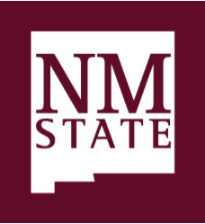

All About Discovery!

Engineering New Mexico Resource Network

engr.nmsu.edu/enmrn